GENERAL INFORMATION

These install notes are for a 95 Z28 (LT1) M6, single cat, with Eibach Pro-Kit lowering springs and Kenny Brown Double Diamond Subframe Connectors (KBDDSFCs). I installed Hooker LT’s, a used custom y-pipe, Taylor cut-to-fit 8mm wires with Made-For-You over the valvecover looms, and removed the air pump assembly. My EGR connections have already been blocked off. I tried to keep good notes on what all I did but some of this is from memory. As best as I can recall, I’ve written this in the order that I actually did the work. Before this install I had a MorFlow y-pipe and high flow cat but that shouldn’t make much, if any, difference for the header install. I did this install by myself over about a week. Don’t let that scare you….my wife was out of town and I had to care for my 19-month old son and could only work on the car for a few hours every night after he went to bed. For those that are interested, here are some approximate lengths for the Hooker LT header primaries. I say “approximate” because I measured them with a string and then measured the string with a tape measure:

Cylinder #1 - 32.5" Cylinder #2 - 34.5"

Cylinder #3 - 30.5" Cylinder #4 - 28.5"

Cylinder #5 - 29.25" Cylinder #6 - 30.5"

Cylinder #7 - 27.5" Cylinder #8 - 27.25"

I bought the used, custom made y-pipe (Figures 1, 2 & 3) from a local guy that had an A4 Z28. I was concerned with how things were going to work out with this but they turned out ok with a few slight modifications. The y-pipe is a 3” non-mandrel bent pipe with a 3-3.5” Y adapter and O2 sensor bungs. I ended up plugging these bungs since my headers have them in the collectors, but they’ll come in useful if I ever get to a dyno with a wideband.

Figure 1: Used custom 3” to 3.5” Y-pipe with O2 bungs

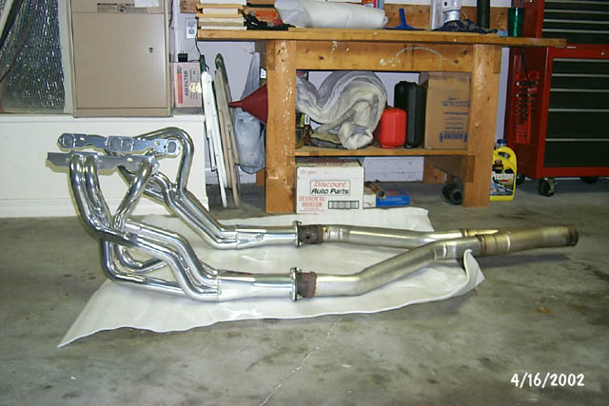
Figure 2: “Dry fit” of the headers and y-pipe (side)

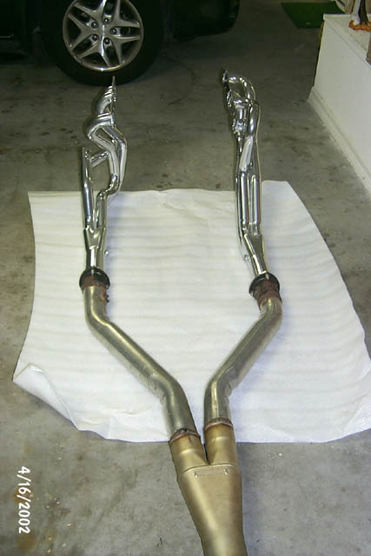
Figure 3:“Dry fit” of the headers and y-pipe (rear)
NOTES

I have a good assortment of tools so I wasn’t lacking in that area. Some possibly “not so common” tools that I found useful were:

3/8”-drive, 1”-long extension

deep well sockets

O2 sensor socket

Allen wrench for the Stage8 header bolts

Allen head socket for the Stage8 header bolts

Open-ended wrench for the Stage8 header bolts

Torque wrench

Dremel with cut-off wheel

Right-angle grinder with grinding disk and a cut-off wheel

Rhino ramps

Floor jack

Chunks of 4x4 and 4x6 wood for supporting the car

Step ladder! When the car’s real high, I needed this to access the top of the engine bay

KY jelly and q-tips ☺

Mechanix gloves

PREP WORK
- Heat shield the fuel lines under the car (Figures 4 & 5). I used DEI Cool Tape and did this before the headers were even delivered, although the picture was taken after the install.

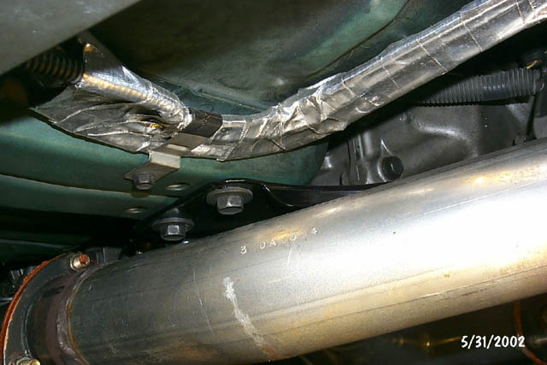
Figure 4: Heat shielded fuel lines 1
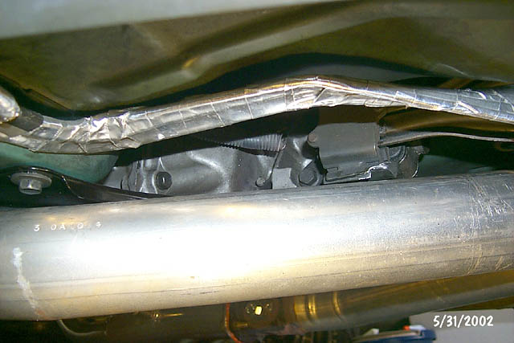

Figure 5: Heat shielded fuel lines 2

- Fit-check the #1 primary slip-fit. Mine was tight enough that it wouldn’t insert at all so I took some sandpaper and lightly sanded the joint. I’m sure the added thickness of the JetHot coating was causing the tight fit. I cleaned it up, lathered on some anti-seize and they went together with a twisting motion. You want this joint to be tight so don’t go overboard with the sanding.
- Wrap headers with masking tape if you want to minimize the potential for scratches. I taped mine and still got a few minor scratches, but no big deal. Don’t go overboard because removing it, once they are installed, will be more difficult! I found it was easiest to run tape down the length of the tubes rather than wrapping it around the tubes, except for the collector since that’s easy to get to once the header is installed. After I did this Brent Franker offered another trick: use Ace bandages instead of masking tape. They’re easier to work with and much easier to remove!
- Disconnect battery. I just removed mine since I knew I’d be leaning all over it while doing the passenger side header.
- Remove serpentine belt (1/2” socket on the tensioner to rotate it out of the way and remove the belt)
- Remove alternator. Several ½” bolts, the main battery wire, and the weatherpack connection on the bottom. I also removed the bracket that attaches to the intake manifold stud (9/16”) just to get it out of the way. Don’t drop the nut and washer that’s on the back side of the bottom alternator bolt….I’ve lost them once before!
- Jack up the car. I did mine in stages to keep things easy to reach. Figure 6 is the “Stage 1” height that I used for removing the stock stuff. Note that I eventually turned the rear Rhino Ramps around the other way to keep the car from rolling backwards (along with setting the parking brake and putting the tranny in gear).

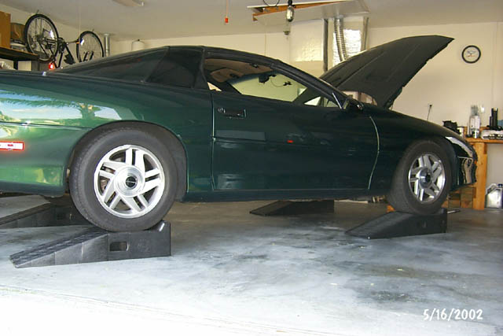
Figure 6: “Stage 1” car height

- Soak driver and passenger manifold bolts with PBlaster or some other penetrating lubricant. Also hit the manifold to y-pipe bolts/nuts and the flange bolts that connect the cat to the intermediate pipe. I did this a couple of times the day before I was going to start the install. All my bolts came out with no problem. I found that the rearmost manifold bolts on both sides were actually a bit loose!
- Remove the air intake tubing. I’ve got a Moroso Cold Air Intake (CAI) so I disconnected it from the K&N filter and the throttle body to remove it. Don’t forget to disconnect the air temp sensor, opti vent line, MAF electrical connector, and the tube to the air pump. Since the Hooker LTs don’t have air connections and I’m removing the air pump, I had to plug the air tube fitting on the CAI. I used a rubber plug that I got from ACE hardware (Figure 7). I wanted to make sure I got a good, tight fit so I got one that was tapered and it took some force and some twisting to get it in there. I tried using some RTV to lube it and seal it, but I ended up wiping it all off since it just lubed it too much and caused it to pop back out.

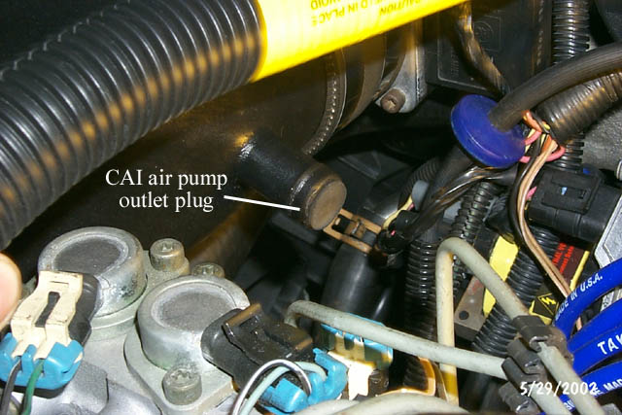
Figure 7: CAI air pump connection plug

DRIVER SIDE HEADER
- Detach air injection fitting from driver side exhaust manifold (Figure 8). I used a big crescent wrench. I then disconnected the rubber tubing from the metal tubing and removed the whole check valve assembly.

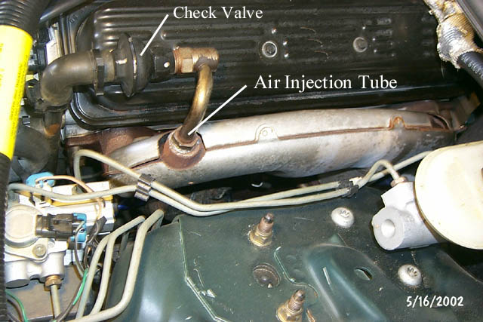
Figure 8: Driver side air injection fittings

- Disconnect the coolant sensor wire from the sensor in the side of the block (between cylinders 1 and 3 – see Figure 11) and just let it hang under the car but tuck it out of the way.
- Disconnect driver side spark plug wires and remove the driver side spark plugs. I removed all of mine from underneath the car.
- Disconnect the driver side O2 sensor wires (my connector was at the top, rear of the block) and remove driver side O2 sensor (in the y-pipe for the stock set-up). I used an O2 sensor socket for this (notched down the side for the wires to pass through).

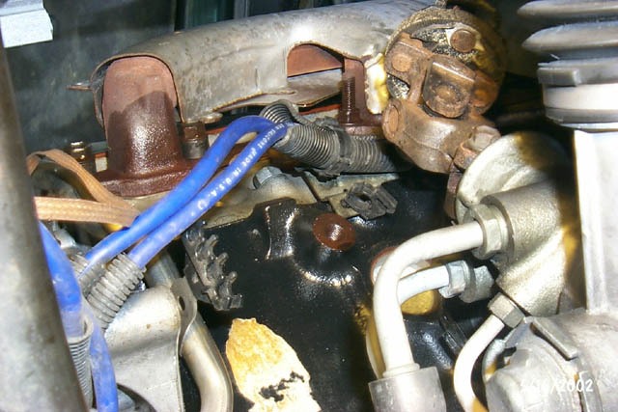
Figure 9: Driver side exhaust manifold from below (front)

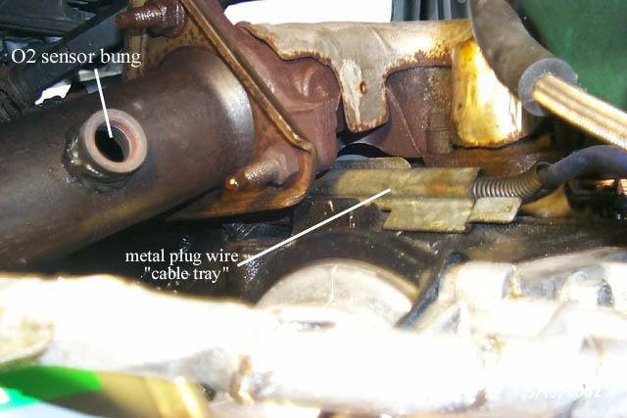 Figure 10: Driver side exhaust manifold from below (rear)

- Loosen all the y-pipe and cat bolts and then remove them one-by-one to drop y-pipe and cat. I couldn’t slide the assembly out since my car wasn’t high enough at the time. I just jacked it up enough to slide it out and then let the car back down on the ramps. You can also remove the exhaust support that hangs off the tranny. I think the support bolts were 15mm bolts but I’m not positive. On at least one of them you’ll need two wrenches to keep the bolt and nut from turning together.
- Remove the stock metal spark plug wire “cable tray” that’s bolted to the block (Figure 10). If I recall correctly, it’s held on by two 3/8” bolts. I moved the spark plug wires out of the way and let them hang from the Optispark for now.
- Loosen all the driver side exhaust manifold bolts/studs (six 9/16” bolts/studs – Figures 9 & 10), then remove them one-by-one until you can remove driver side exhaust manifold. The gasket fell right out with mine but if it doesn’t, make sure you remove it too. I think I dropped my manifold out the bottom.
- Figures 11 & 12 show you how things look with the manifold removed.
- Figures 13 & 14 show how the driver side exhaust manifold compares to the driver side Hooker LT:

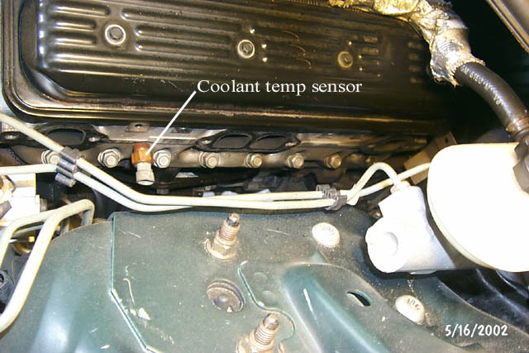
Figure 11: Driver side exhaust ports (from top)

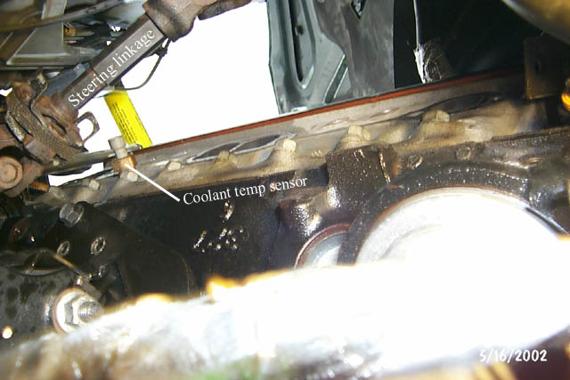 Figure 12: Driver side exhaust ports (from bottom rear)

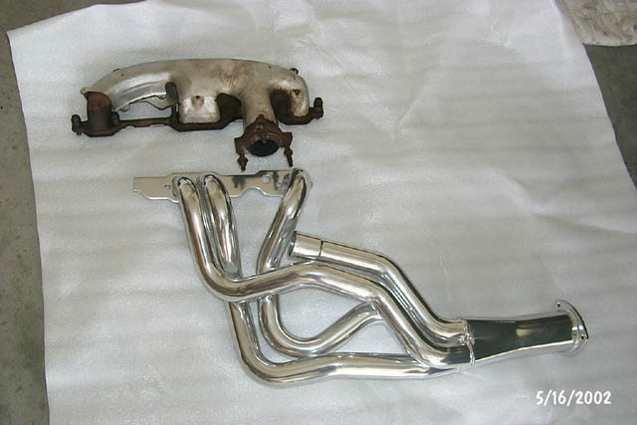
Figure 13: Stock exhaust manifold vs. Hooker LT

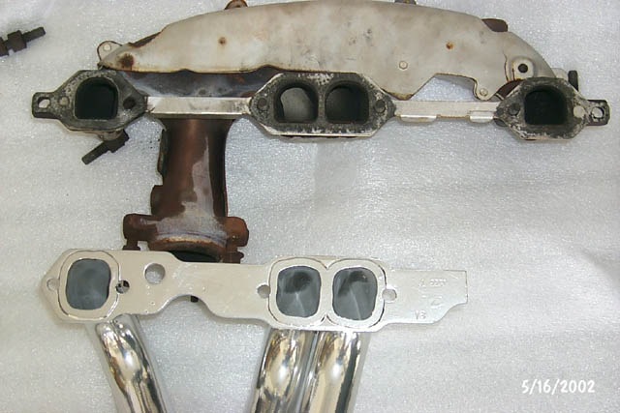 Figure 14: Stock exhaust manifold vs. Hooker LT (ports)

- Clean head surface where the gasket and header flange will contact it. I used some WD40, a small brass brush, and some paper towels to clean things up.
- Hold the #1 primary tube up to the block and eyeball where it will come closest to the metal heat shield (Figure 16) covering the brake lines. Remove the heat shield (3 bolts) and pound it flat where the #1 primary will cross closest to it. I used some small pieces of 2x4 and a hammer.
- Heat shield the ABS sensor wires running down the inside of the fender well (Figure 15). I used DEI Cool Tape and it worked great.

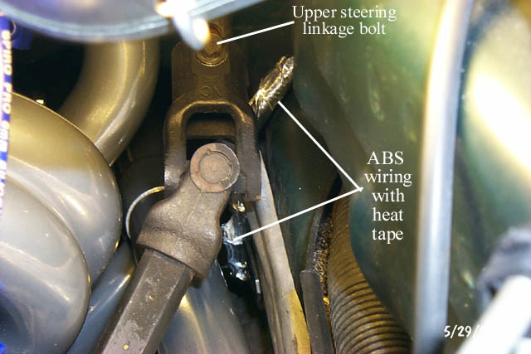
Figure 15: Driver side heat-wrapped ABS wires

- Go ahead and hook up your O2 wire extender and route it out of the way. It’ll be easier to do this now since the headers aren’t installed yet and it connects high on the block.
- Re-route the cruise control cable behind the metal brake line heat shield and bolt the shield back in place. Hold the #1 primary back up to the block and make sure you’re happy with the clearance. Bend the shield accordingly. Figure 16 shows the routing I used but before I bent the metal shield.

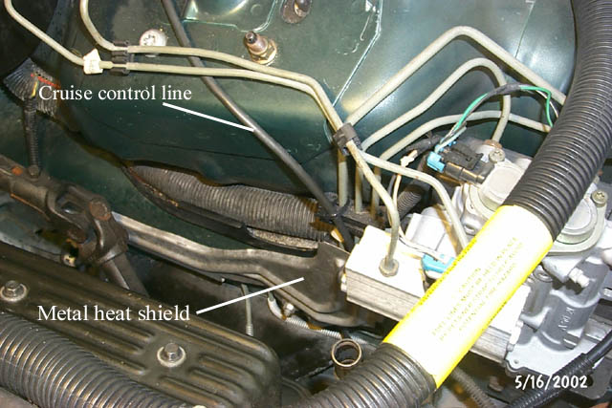
Figure 16: Cruise control cable and heat shield

- Remove steering linkage. My plastic cover had already been removed so I didn’t have to deal with that. There’s a bolt at the top (Figure 15) and a bolt at the bottom (Figure 17). Remove both bolts, grab the bottom of the linkage and slide it up and off of its seat. From there you can pull the upper portion down and remove the whole thing.

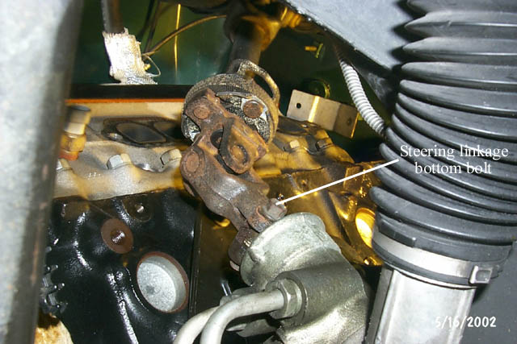
Figure 17: Steering linkage

- Remove oil filter. I typically loosen the filter a bit and then pop a hole in the bottom of the filter with a hammer and punch to let the oil drain out that way (less messy). Let most of the oil drain out, remove the filter, let it drain a bit more, then shove some paper towel in the hole so it won’t be dripping all over.
- Jack the car higher. Figure 18 shows the “Stage 2” height I used for installing the driver side header.

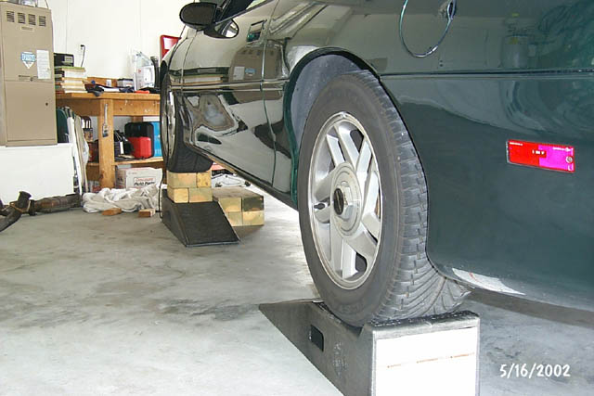
Figure 18: “Stage 2” car height

- Anti-seize driver side header bolts. I used ¾” Stage 8 bolts.
- Install driver side Hooker LT header. Mine slipped in from the bottom with little effort. Just make sure you have the car high enough so you can angle it in steeply. Watch out that you don’t knock the coolant temp sensor in the side of the block (see Figure 12). Once I got it up in there I just let it rest in place while I went up top, removed some of the masking tape from the flange, aligned the gasket (Felpro 1406), and installed a couple of bolts to hold it in place. I didn’t use any RTV. Don’t tighten up the bolts all the way yet. Grab the #1 primary and wiggle/twist that around until you get it inserted in the tube and turned in the correct direction. Once that’s done you can get all the bolts started and “finger tight”. After that, I used an assortment of allen wrenches, allen sockets, and open-ended wrenches to torque the bolts tight. I got some from the top by kneeling on the radiator support (step ladder came in handy here) and some from the bottom by lying on the ground.
- Install the Stage8 clips. This wasn’t as bad as I thought it would be, as long as you don’t drop them! If the “retainers” don’t line up well, eyeball how they should be trimmed to work. Keep in mind that you want to keep the bolt from turning counter-clockwise and trim accordingly with some tin snips. I used a bastard file to smooth out the rough edges after cutting. I didn’t take any pictures at this point so you’ll have to wait until the plug wire section!
- Remove any masking tape if you put any on the headers before the install.
- Reinstall the steering linkage in the reverse order from how you removed it. It may take a little work to get the bottom portion back in place but it will go. Don’t forget to tighten the upper and lower bolts.
- Install the O2 sensor and zip tie the wire extender to the tranny so it won’t be hanging under the car or contacting the header anywhere.
- Fill a new oil filter with oil or reinstall the old one (if you didn’t knock a hole in it).

PASSENGER SIDE HEADER
- Disconnect the air pump fitting from passenger exhaust manifold. I don’t have a picture of this but it’s just like the one on the driver side (see Figure 8). I used a big crescent wrench again. I also disconnected the rubber tubing from the metal tubing and removed the whole checkvalve assembly.
- Here’s a picture of the passenger side exhaust manifold, from below, before I removed much of anything:

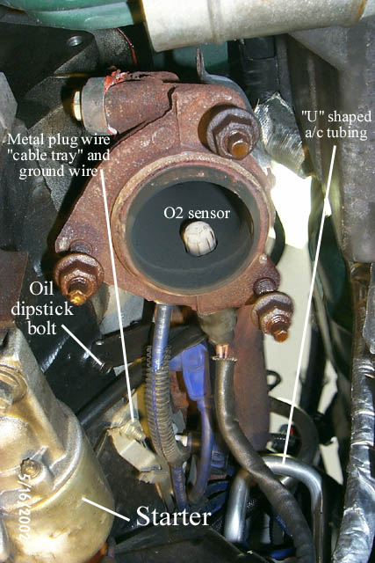
Figure 19: Passenger side exhaust manifold (from bottom rear)

- Remove starter (lower left in Figure 19). Disconnect the small wire running to the solenoid and the large wire that runs down from the battery (runs along the oil pan). Then remove the two large bolts holding the starter to the block.
- One of the motor mount studs (on the block side) had a ground wire and metal wire support connected to it. I disconnected these but I don’t really recall if it was necessary.
- Disconnect the O2 sensor wire and remove the O2 sensor from the passenger side exhaust manifold (Figure 19). I used a crescent wrench for this one.
- Disconnect passenger side spark plug wires and remove passenger side spark plugs
- Once again, remove the stock metal spark plug wire “cable tray” that’s bolted to the block (Figure 19). The rear attachment point is actually a stud and nut that’s screwed into the block and has a ground wire tied to it (Figure 19). Retain the stud and the nut so you can reattach the ground wire later. I just moved the spark plug wires out of the way and let them hang for now.
- Disconnect the knock sensor wire from the knock sensor
- Loosen power steering pump (two 10mm bolts that can be accessed from the front, through the holes in the power steering pulley). This will help in accessing the alternator bracket bolt and the first passenger side exhaust manifold stud.
- Remove the nut holding the alternator bracket to the first passenger side exhaust manifold stud. Wiggle the power steering pump to get it out of the way if needed. Once that was done I ditched the bracket since it’s not really needed and won’t work with the Stage8 header bolts.
- Loosen all the passenger side exhaust manifold bolts/studs (six 9/16” bolts/studs), then remove them one by one until you can remove passenger side exhaust manifold. The gasket fell right out with mine but if it doesn’t, make sure you remove it too. I think I dropped my manifold out the bottom.
- Remove oil dipstick tube bracket bolt (Figure 19) and remove the oil dipstick tube. From under the car I just grabbed the tube with my hands and twisted it back and forth while pushing it up and out of the hole. Mine came right out. Thread the bracket bolt back into the block so you don’t lose it.
- See Figures 20 & 21 to see all the room you’ve just made for yourself to work with.

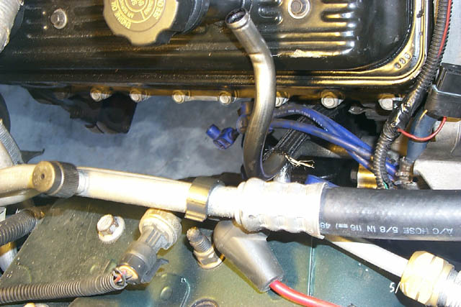
Figure 20: Passenger side exhaust ports (from top)
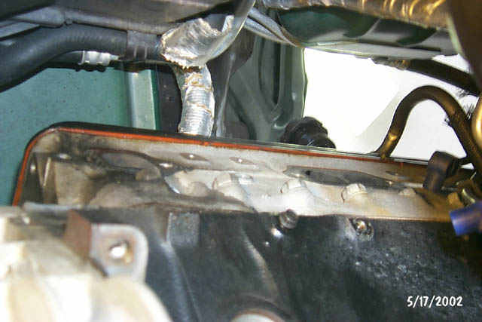
Figure 21: Passenger side exhaust ports (from bottom)

- Clean head surface where the gasket and header flange will contact it. I used some WD40, a small brass brush, and some paper towels to clean things up.
- Remove air pump and the air pump bracket (Figure 22). To remove the air pump, disconnect the electrical connector from the bottom, disconnect the rubber tubing from the metal tubing and loosen the three bolts that hold the pump to the aluminum air pump bracket. Once these are loosened you should be able to pull the air pump out from the bottom. Now loosen the 2 bolts that hold the aluminum bracket to the block and remove it too.
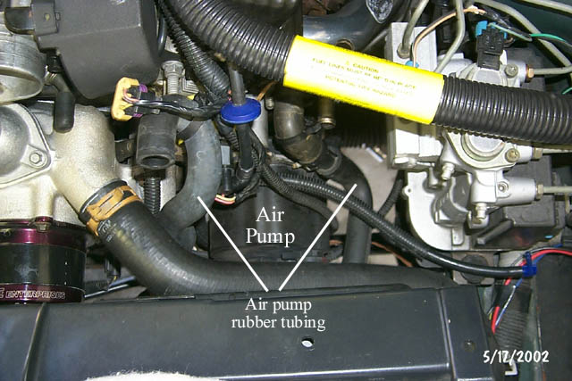
Figure 22: Picture of installed air pump

- Remove the metal air pump tube that runs under the front of the oil pan (Figure 23). I used a Dremel with a cut-off wheel with no problem. Once that’s done you can finagle the metal tubes out from the bottom of the car.

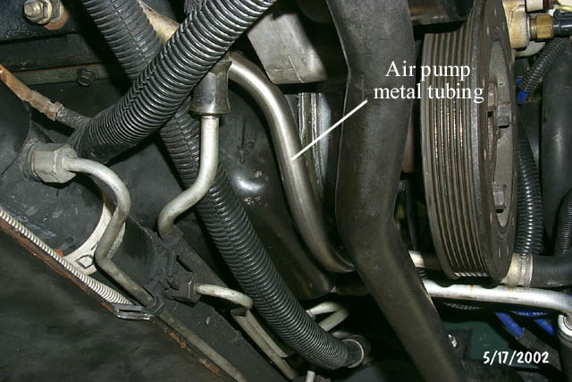
Figure 23: Picture of air tube running under oil pan

- For the electrical connector that was left hanging, I wrapped it in electrical tape and secured it out of the way (Figure 24).

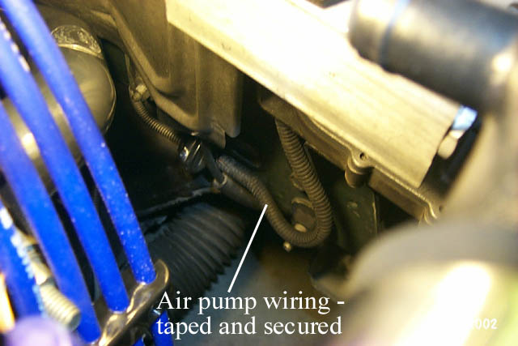
Figure 24: Taped and secured air pump wiring

- See Figure 25 for a picture of all the air components removed.

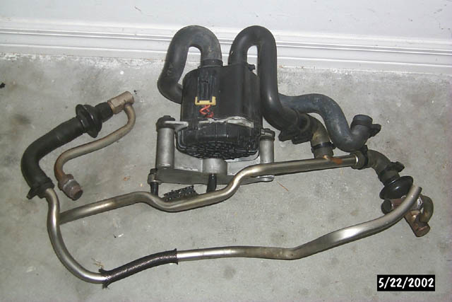
Figure 25: Removed air pump, air pump bracket, and air pump tubing

- Lengthen starter solenoid wire, ground wire, and the knock sensor wire, and hook up your O2 sensor wire extender. All these wires are in that single bundle that runs down the inner passenger side fender well. To do this, remove and discard the plastic clip that holds the wire bundle to the lower control arm (we’ll re-route these wires and won’t need the clip anymore). I routed these up to the top of the car, cut the wires, and installed an additional 8-9” of wire using butt connectors and electrical tape. I had a heat sleeve for this bundle (Figure 26) so I fed the wires through that and then wrapped some additional heat tape around the end. This allowed me to route the wires more forward and down through the motor mount, keeping them well away from the header primaries. I ended up zip-tying them to the a/c lines, the coolant lines that run back to the firewall to the heater core, and passing through the “u”-shaped tubing on the back of the a/c compressor (Figure 27). This resulted in at least 1-2” of clearance between the bundle and the header primaries.

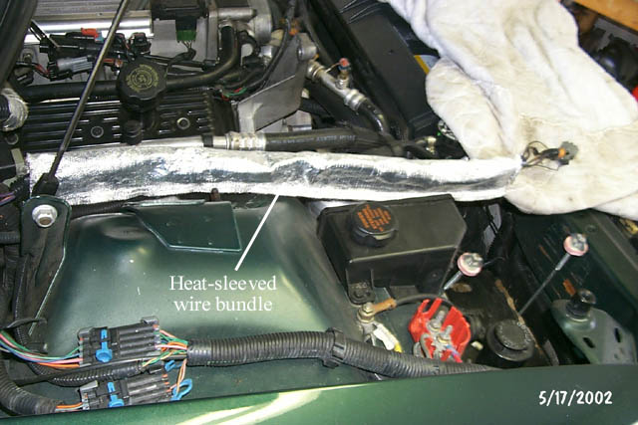
Figure 26: Heat--sleeved wiring

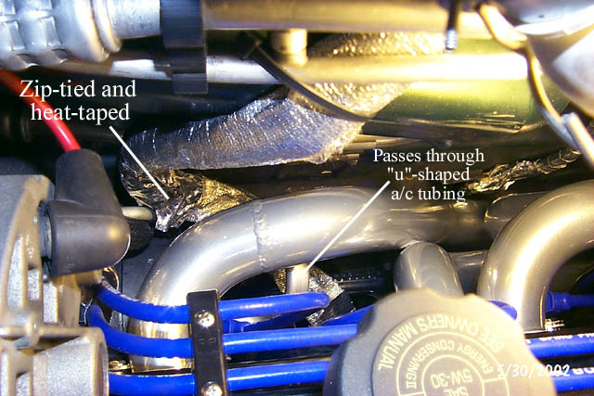

Figure 27: Heat-sleeved wire routing

- Heat wrap the ABS sensor wires running down the inside of the fender well. I used DEI Cool Tape and it worked great (Figure 28).
- Install heat shielding on the a/c box. I used the Thermo-Tec adhesive-backed aluminized heat shield. I roughly measured the shape I’d need and then cut the pattern out. It was a little stiff but that was good because it let me stick it in there and pre-form it before removing the paper on the back, exposing the adhesive. Once you get the shape, remove the paper and stick it in place (Figure 28).

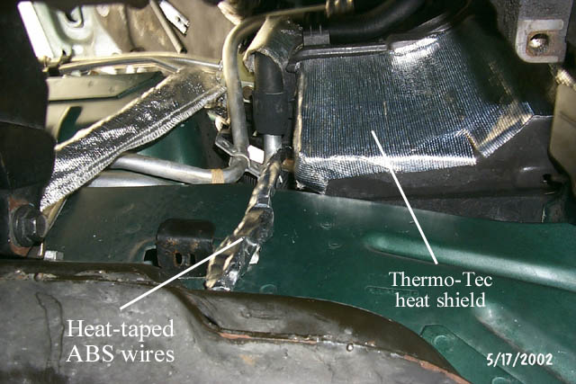
Figure 28: Heat-sleeved ABS wires and a/c box heat shield

- Remove passenger spark plug wires. I just disconnected them from the Opti and the stock looms and pulled them from the top. This is easier if you loosened the power steering pump like I mentioned earlier. I re-used the stock looms later so I left them in place. There is a small loom a few inches from the Opti, sort of behind the serpentine belt tensioner, that I disconnected and re-used too. It clips on a small metal bracket to hold it in place (Figure 35).
- Anti-seize passenger side header bolts
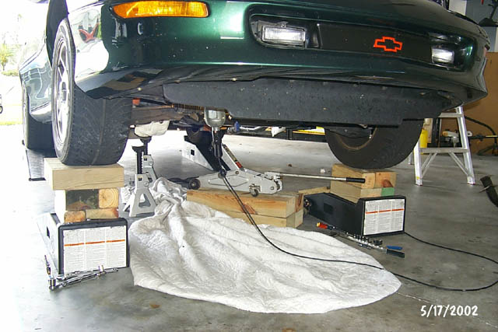
Figure 29: “Stage 3” car height

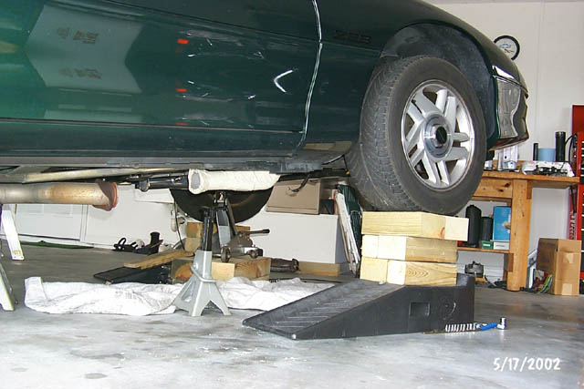

Figure 30: “Stage 3” car height

- Raise the car higher (Figure 29 & 30). I used some 4x6 wood pieces to set my jack on and raised the front end enough to insert some additional wood spacers between the passenger front wheel and Rhino ramp to get to “Stage 3” height. Some folks have been able to install the passenger header without jacking the motor. I had tried that first but I couldn’t get it to work. It’s worth a try but if you have to jack the motor…..slightly raise the motor at the tranny bell housing and remove the passenger side motor mount bolt. I replaced my motor mounts a few weeks earlier so this was really easy. At the time I did the motor mounts I reversed the way the passenger side bolt went through the mount and that made it easier this time. I suggest you do this if you haven’t done it before. I used the 4x6 wood pieces to set my jack on and had a 2x4 piece of wood between the jack and bell housing. I liked this better than using the oil pan or crankshaft as a jacking point. Once you’ve wiggled the motor mount bolt out, raise the motor with the jack to create room for header to be inserted.
- I angled the header as shown in Wayne Edelen’s picture (Figure 31) and it slipped right in easier than the driver’s side header! Once I got it up in there I just let it rest in place, with a jackstand under the collector to support it, while I went up top, aligned the gasket (Felpro 1406), and installed a couple of bolts to hold it in place. I didn’t use any RTV. Get all the bolts started and get them “finger tight”.

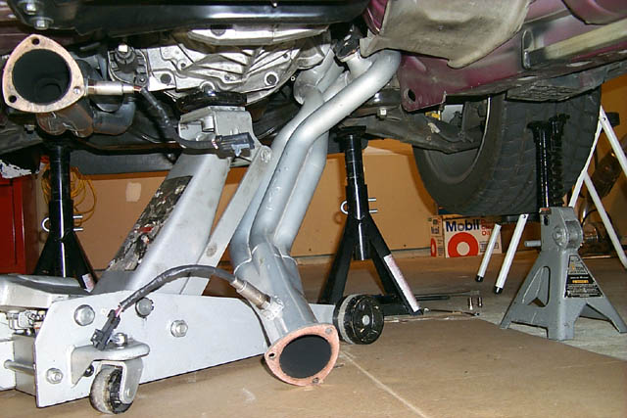
Figure 31: Wayne Edelen’s passenger side header picture

- Lower the motor slowly and reinstall motor mount bolt. Once again, it may take several iterations of lower and raising the jack to get things lined up and get the motor mount bolt to wiggle back into place. Once you get the bolt pushed through enough you can get the nut started and draw it through the rest of the way.
- I jacked the car back up, removed the extra spacing from the passenger side, and returned the car back to the “Stage 2” height (Figure 18).
- I then used an assortment of allen wrenches, allen sockets, and open-ended wrenches to torque the bolts tight. I got some from the top by kneeling on the radiator support (step ladder came in handy here) and some from the bottom by lying on the ground.
- Install the Stage8 clips. This wasn’t as bad as I thought it would be, as long as you don’t drop them! If the “retainers” don’t line up well, eyeball how they should be trimmed to work. Keep in mind that you want to keep the bolt from turning counter-clockwise and trim accordingly with some tin snips. I used a bastard file to smooth out the rough edges after cutting.
- Install oil dipstick tube. I ended up cutting 1.5” off the end that goes into the oil pan. This helped in getting it back in but I still needed to bend it a little. It wasn’t that bad but since I was alone I’d have to try it, bend a little, try it, bend a little more….etc. Once I got the tube all the way in the bracket wasn’t lining up with the bolt hole. I had to bend the bracket a little closer to the tube and everything lined up and I was able to reinstall the bolt.
- Reconnect all the starter/knock sensor/ground wires, taking care to keep them away from the header tubes.
- Install the O2 sensor and zip tie the wire extender to the tranny so it won’t be hanging under the car or contacting the header anywhere. Remove any masking tape if you put any on the headers before the install.
- See Figure 32 for a picture of the collectors

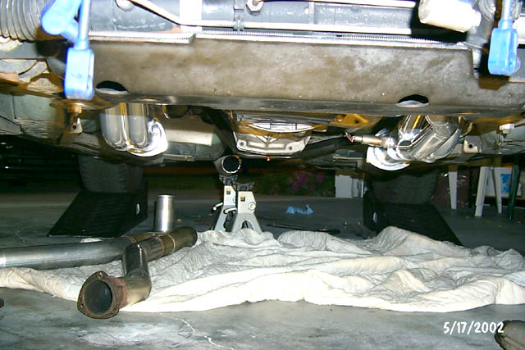Figure 32: Hooker LT collectors (from front)

TAYLOR OVC SPARK PLUG WIRE INSTALLATION

- Install all the spark plugs. I found I could do all of them from the top using a sparkplug socket, ratchet and various extensions, or an open-ended wrench. I always use a little anti-seize on the threads.
- Lube the sparkplug boots on the new wires with the supplied dielectric grease and start hooking them up to the sparkplugs. Logically, I put the shorter wires on the cylinders closest to the Opti but I routed each one to make sure I didn’t have any wires that would end up too short. I didn’t, so now the fun starts. The wires had to be the worst part of this whole job!
- Remove the front three valvecover bolts and loosen the rearmost one on each valvecover.
- I started on the passenger side first. I decided to use the stock wire looms and routed them starting with the “lowest” wire first. If you look at the Opti from top to bottom on the passenger side, the wires are 4-6-8-2, so I started with #2, then #8, then #6, and finally #4.
- Install the Taylor valvecover bolts and bottom section of the looms in the front three vavlecover holes. Be sure not to drop any of the little nuts that tend to fall out of the bottom of the looms!! Route the wire off the spark plug so that it won’t be contacting any on the header primaries. Then, route the wire through the bottom section of the Taylor looms it’ll be passing through, down around the stock loom on the side of the alternator support bracket, around through the stock loom under the power steering pump, and down to the Opti. Cut the wire to fit. I did this for each wire on the passenger side and then pulled them all back up to the top of the engine so I could strip and crimp easier.
- Now’s the WORST part of the whole header installation! I tried everything to lube the Opti boots to make them slide on easier (silicon spray, WD-40, motorcycle cable lubricant) but I found that KY Jelly worked best! Grab a q-tip and lube the inside of the boots really well, where the wire will pass through. Make sure you lube the enter length of the passage. Rub a little on the wire itself and then push the boot over the wire using a twisting motion. Grip the boot with a full hand, rather than just your fingertips, so you won’t inhibit the wire’s travel. I didn’t figure this out until the passenger side wires were done!
- Once the boot is on and there’s a good length of wire sticking out, strip the wire, fold the center conductor back over the insulation, and crimp on the connector. Then, slide the boot down over the crimp….not too far or you won’t be able to get the connector to click into place on the Opti. The Taylor crimpers I bought just plain sucked for cutting the wires so I used a set of standard wire cutters. Do this for each wire and then route them back down to the Opti, using the stock looms.
- Put a little dielectric grease in the Opti boot and connect them to the Opti, making sure you got the order right.
- Now, go back and install the top portions of the Taylor wire looms and screw them together, keeping your wires nice and straight and not losing any of the nuts. Torque all the valvecover bolts to spec (106 in-lbs in my case).
- I used the “4th” Taylor wire loom behind the alternator and heat-taped the wires below that since they were close to the #2 primary (Figure 33).
- Figures 34 & 35 show more detail on the passenger wires and the stock wire looms.
- I followed the same procedure on the driver side but routing was a lot easier since NOTHING is in the way and there was no need to use any stock wire looms. If you look at the Opti from top to bottom on the driver side, the wires are 5-3-7-1, so I started with #1, then #7, then #3, and finally #5.
- I used the “4th” Taylor wire loom where the driver side wires turned down in front of the engine (Figure 36).

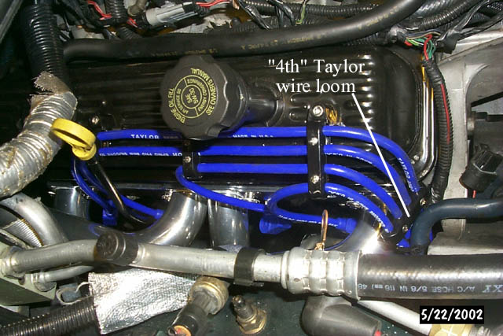
Figure 33: Passenger side wires (valvecover)

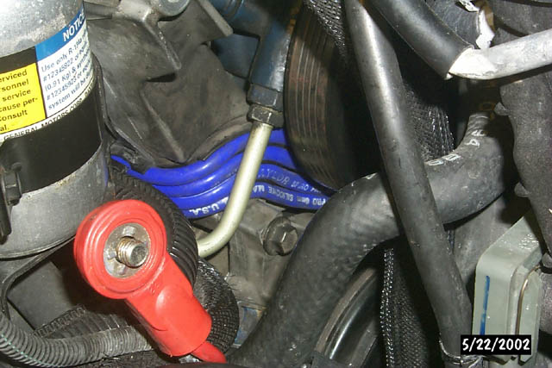
Figure 34: Passenger side wires (under alternator)

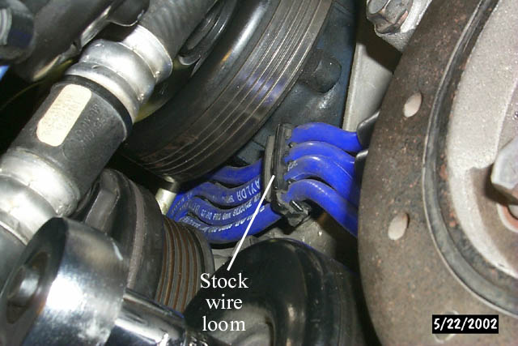
Figure 35: Passenger side wires (p/s pump and Opti)

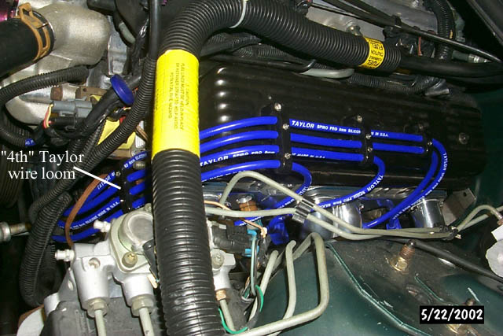
Figure 36: Driver side wires

YOU MUST FIRE IT UP WITH OPEN HEADERS!!
- Reconnect coolant temp sensor wire to coolant temp sensor on driver side block (Figure 11)
- Install CAI. Don’t forget to plug the air connection if you haven’t already (Figure 7).
- Install alternator (without the brace to header bolt)
- Install serpentine belt
- Install/reconnect battery
- Check oil level. Just make sure you replaced whatever you lost if you removed the oil filter.
- Double check that you’ve connected all the wiring and make sure nothing is touching the headers.
- Fire it up and bother your neighbors!!! I was really hoping the ricers across the street would have been home for this, but they weren’t!

Y-PIPE INSTALLATION
- I wasn’t quite sure how well the y-pipe was going to fit with the headers and my tranny cross-member. The M6 tranny cross-member is a bit different than the A4 one and although I had done some eyeballing and grinding on it already I wasn’t sure how well it would work.
- I removed the g-load brace, held the y-pipe up, and eyeballed where I should cut the intermediate pipe and marked it with a Sharpie. I got out my grinder with a cut-off wheel and cut it quick and dirty, just enough so the y-pipe would fit up in there without the slip-fit reducer on the end. I supported the intermediate pipe with a jackstand.
- From there I realized that 2 of the 3 the driver side collector bolts weren’t lining up very well. It turns out that the driver side of the y-pipe was contacting the rear of the tranny cross-member. Off came the support and out came my grinder and some black paint. Figures 37 shows the initial grinding I did while Figure 38 shows the additional grinding needed to clearance things.

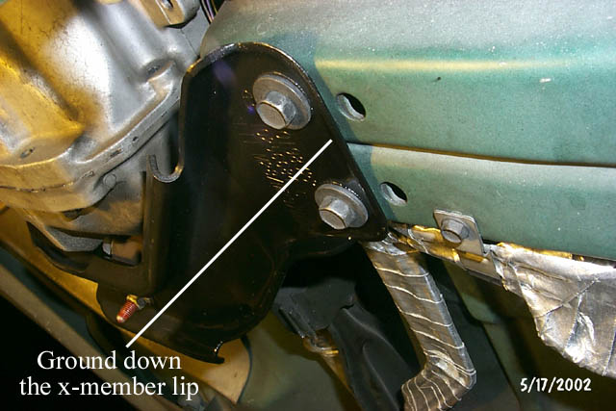
Figure 37: Picture of tranny cross member mods

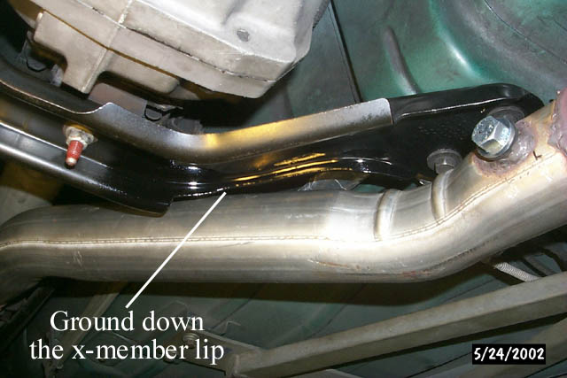
Figure 38: Picture of tranny cross member mods 2

- This helped the problem but the 2 of the 3 collector holes still weren’t perfect. Out came the Dremel again so I could slightly widen the collector bolt holes in the y-pipe. I think the header flange on my driver side header must have been slightly different in orientation from the one that this custom y-pipe was fitted to. With that, all was well up front but I still needed to tackle the back end of the y-pipe.
- The reducer I got with the used y-pipe was a slip-fit to the 3.5” Y output but was a butt fit to the rest of my exhaust system. Therefore, I needed a nice, straight, even cut so I could use a 3” stainless bandclamp I had lying around. I slipped the reducer onto the y-pipe, bolted the y-pipe to the collectors, and supported the back end with a jackstand so I could see exactly where I needed to cut. I marked it with a Sharpie and then disconnected the y-pipe to get it out of the way.
- Next, I wrapped the band clamp around the intermediate pipe so I could mark a nice, straight line around the circumference of the pipe. With that, I broke out my Dremel and got to work. I could have used my grinder but space was limited and I don’t think I would have gotten a straight, even cut. An hour and several cut-off wheels later, I was done.
- I did a “dry” fit and things fit perfect! I went ahead and installed the band clamp to secure the reducer to the intermediate pipe (Figure 39). I torqued it to spec and haven’t had any leaks so far.
- Since I had 2 sets of Felpro collector gaskets I decided to RTV them together and use “double gaskets” on each collector.
- I anti-seized the slip-fit and slid the rear of the y-pipe into place. I ran a bead of RTV on each side of the collector gaskets, bolted the y-pipe to the collectors, and torqued down the bolts (3 on each collector).
- The g-load brace won’t clear the new y-pipe so I just left it off. I’ll have to see about getting an aftermarket one with a driveshaft loop.
- Figures 39, 40, & 41 show the installed y-pipe.

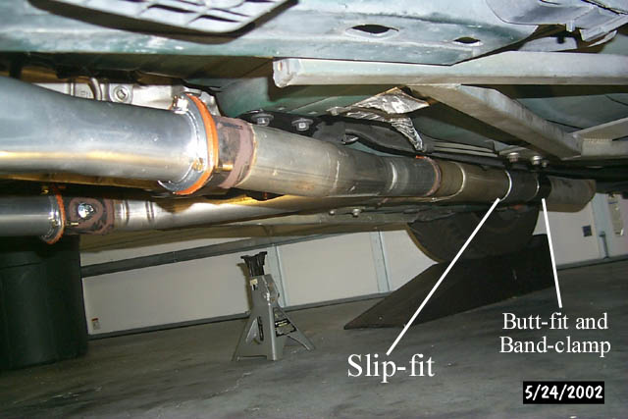
Figure 39: Driver side of the installed y-pipe

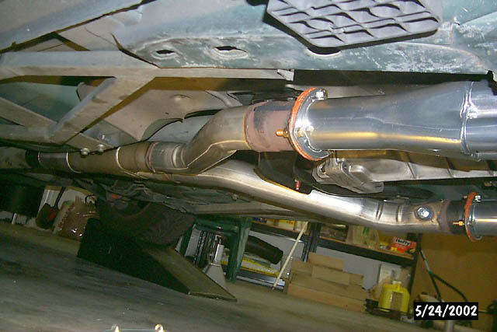
Figure 40: Passenger side of installed y-pipe

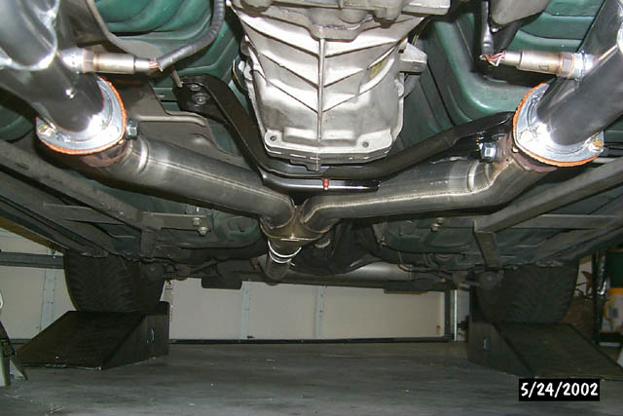 Figure 41: Y-pipe installed

CLOSING NOTES AND GROUND CLEARANCE

- See Figure 42 for a full engine shot showing the Taylor OVC wires and headers installed.
- Ground clearance (Figures 43-45) is minimal (2.25” at the collector flange) on the driver side but I don’t ever go over speed bumps and I haven’t scrapped yet, although it’s only been on the road for a few hundred miles <KNOCK ON WOOD>. Remember that I’ve got Eibach Pro-Kit lowering springs.
- By the way, I finished things up before my wife got back in town and I was dying to drive it, so I had to install the carseat and take my 19-month-old son with me. I ended up driving the car for the next couple of days because he LOVED it and would pitch a fit when we got home and it was time to get out. THAT’S MY BOY!!!

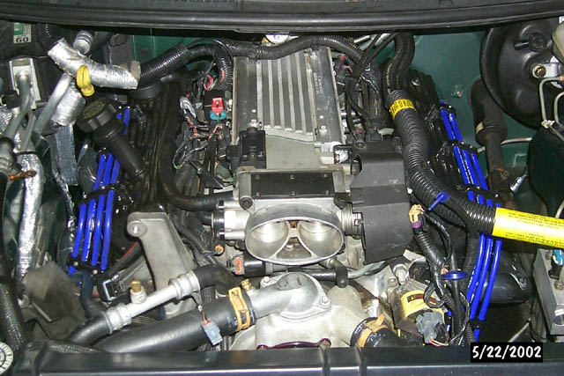
Figure 42: Engine with Hooker LTs and Taylor OVC wires

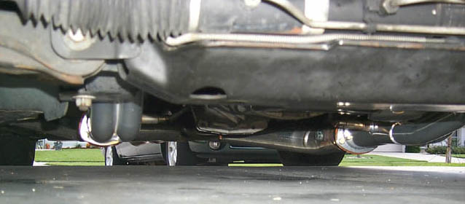Figure 43: Ground clearance, front view

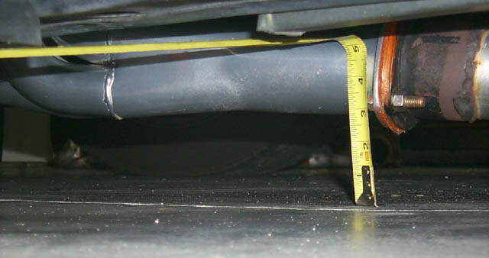
Figure 44: Ground clearance, driver collector 1

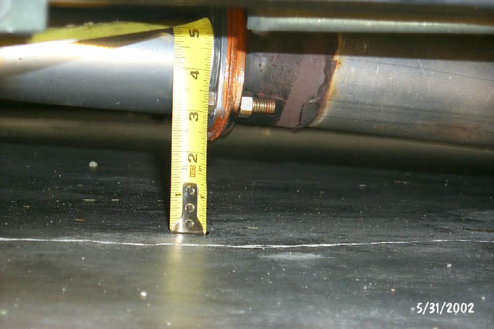
Figure 45: Ground clearance, driver collector 2

